menu
coffee. reg
americano 3.15
cappuccino 3.30
latte 3.30
flat white 3.60
mocha 3.80
Iced coffee from 4.20

hot chocolate. bear adult
milk from 1.45 2.90
dark from 1.95 3.40
white from 1.95 3.40

tea. Cup Pot 1 Pot 2
Yorkshire tea 2.20 3.20 4.40
decaf tea 2.20 3.20 4.40
earl grey 2.40 3.40 4.60
peppermint tea 2.40 3.40 4.60
green/camomile tea 2.40 3.40 4.60

soft drinks. from 1.00
coke, diet coke, fanta, fanta zero, fanta lemon, sprite, Victorian lemonade, rose lemonade, elderflower, orange & mango water, lemon & lime sparkling water, cherry & berries sparkling water, passion fruit & pineapple water, bottled still water

add-ons
cream 0.50
marshmallows 0.50
add-ons
alternative milk
syrup 0.50

sweet treats.
cakes from 3.50
traybakes from 2.40
sweet muffins 3.20

GF options 3.95
vegan options 4.10

breakfast.
subject to availability after 12noon
bacon butty 3.45
sausage butty (VG Available) 3.70
fried egg butty 3.10
add-ons
bacon, sausage, egg, beans from 0.75
toast (2 slices) from 2.95
teacake 3.60
served with jam and butter
lunch.
served with a side salad with a balsamic glaze & crisps
toasties 4.95
served on a soft white or brown bread (GF available)
choose from one of the following fillings:
panini from 5.45
served on a soft white panini bread (GF available)
choose from one of the following fillings:

pulled pork & cheese Tuna Melt
chicken tikka & cheese Cheese & ham
mozzarella, tomato & pesto Cheese & onion
ham, cheese & chutney Cheese
chicken & bacon

Rainbow Salad (GF) from 5.20
Containing lettuce, tomatoes, cucumbers, peppers, sweetcorn, red onion with a choice from any of our listed fillings

jacket potatoes (GF) from 5.45
includes one filling from below (additional fillings are extra)
fillings (additional fillings are extra at 0.75)
beans cheese** pulled pork
tuna mayo red onion chicken tikka
chicken

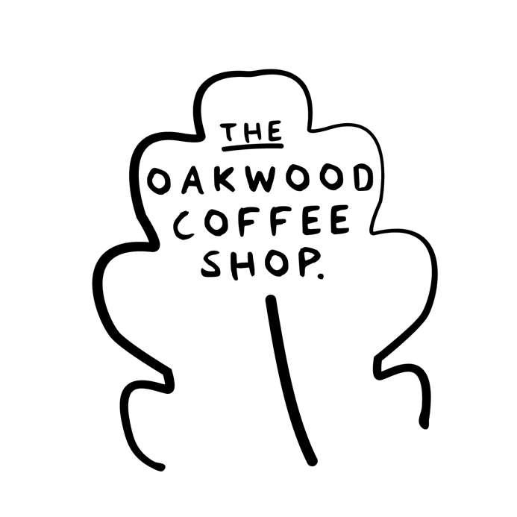
See our specials board for seasonal fillings

**we have vegan cheese available

add-ons
whip cream 0.30
ice cream 0.75

